Auto-drafting – a good place to start
Auto-drafting is an electronically-operated gate that automatically sorts cows via their Electronic Identification (EID). Cows are typically auto-drafted for mating, treatments, pregnancy testing or vet checks. In 2018, 38% of dairy farms in NSW were using auto-drafting.
Auto-drafting saves time and labour and contributes to a safety by reducing cow handling. Many farmers described it as fundamental – “you can’t get best value from other tech unless you can auto-draft cows”.
Farms in the TechKISS project shared tips about making auto-drafting work on their farms, particularly how to achieve smooth cow flow. These included:
- When choosing a system, ensure the EID use in the herd can operate the gates (not all do).
- Design the race, gate and yards so cows move evenly. Ensure the race has good forward visibility, is 2+ cow lengths at entry and exit, and is a width that won’t allow cows to pass. The receival yard should be able to hold about twice the number of cows to be drafted.
- Ensure the gate is fast-acting (so cows can’t jam it) but not too noisy. Have sufficient reserve air capacity but put the reserve tank far enough away to control noise. And use rubber to stop clanging.
- Locate EID readers well before the cows reach the gate and where they can be cleaned regularly.
See all their tips and traps in short videos and info sheets on the NSW Department of Primary Industries website (search for ‘dairy technologies’).
[240 words, one image]
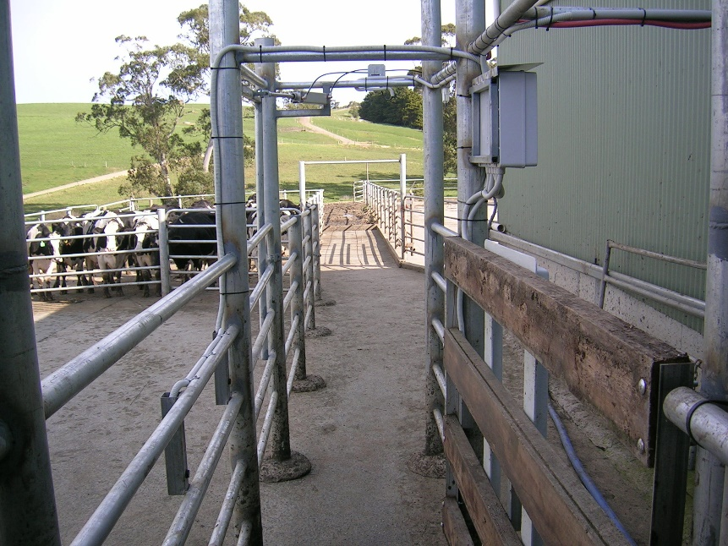
Auto-draft gate in a long race with good forward visibility.

