Making in-line milk meters work well for you
In-line milk meters generate data on milk production and the milking process for every cow at every milking. All meters measure milk yield. Some test biological indicators for mastitis, nutritional or reproductive status. This info can be used to assist with drying-off and culling decisions, managing mastitis and milk quality and tracking responses to changes in feed.
In 2018, 26% of dairy farms in NSW had in-line milk meters and about half of these were able to measure mastitis indicators.
The farmers in the TechKISS project shared tips and traps on making this technology work best on their farms.
- One repeated comment was to “have them located for easy maintenance and calibration” – because, like all milk harvesting equipment, in-line meters need regular maintenance.
- Ensure effective cleaning of meters. Water quality (hardness), temperature and reagents are all important.
- Calibrate meters on a regular maintenance schedule and after modifications and repairs.
Other tips were around acting on alerts.
- Have pre-set protocols for different types of alerts (mastitis, health etc)
- Train farm staff, including casuals, so they know what to do.
See all their tips and traps in short videos and info sheets on the NSW Department of Primary Industries website (search for ‘dairy technologies’).
[200 words, one image]
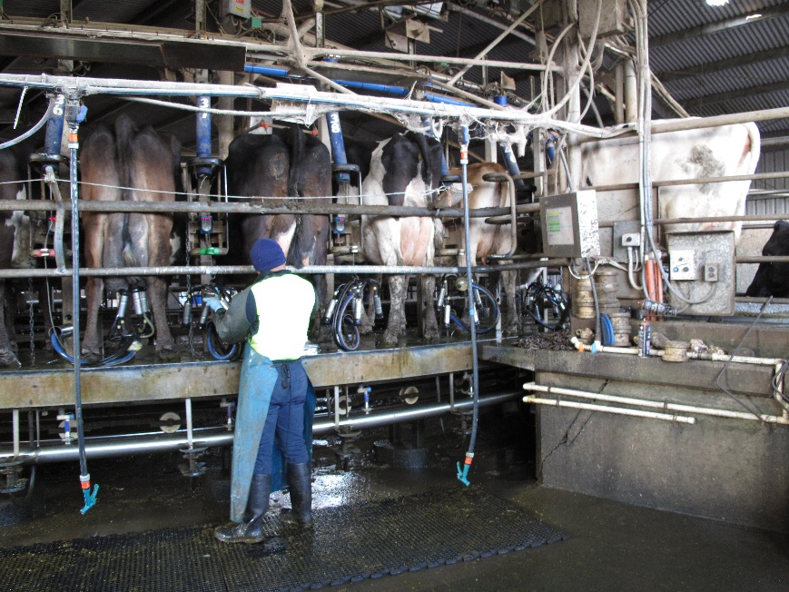
Everyone needs to know what the procedure is for alerts as cows are milked.

